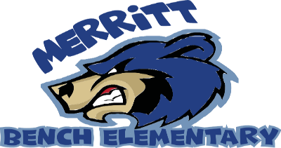
Online Etiquette

“Be Safe, Be Responsible, Be Respectful”
Technology and distance learning
Be Respectful | - I will be kind to others (use kind words and faces)  - I will be supportive of my classmates and be respectful of their ideas  - I will work in a quiet place  - I will stay still (in one spot) for meeting or leave technology in place if I move  - I will mute my microphone if I am snacking, or having another conversation  - I will monitor my screen time
Be Responsibility | - I am respectful of myself and others online  - I will try my best  - I will actively participate  - I will help others who might need it  - I will be on time and ready to learn  - I will follow instructions before asking questions  - I will do my best to complete work and turn it in when requested
Be Safe | - I will not record or take pictures without my teachers permission  - I will use technology appropriately  - I will keep passwords and private information private

